**­­**

**East Central Public School**

**September 2022**

***Principal - Mrs. Joanne Tournier***

***Ph. – 306-922-8329***

|  |  |  |  |  |  |  |
| --- | --- | --- | --- | --- | --- | --- |
| **Sun** | **Monday** | **Tuesday** | **Wednesday** | **Thursday** | **Friday** | **Sat** |
|  |  |  |  | **1 K**  **Classes**  **Begin** | **2** | **3** |
| **4** | **5**  **Labour Day**  **No Classes** | **6 K** | **7** | **8 K**  **Literacy Day** | **9 K** | **10** |
| **11** | **12** | **13 K**  **Meet the Staff**  **5:30 – 6:30**  **SCC Meeting**  **6:30** | **14** | **15 K** | **16** | **17** |
| **18** | **19** | **20 K** | **21** | **22 K** | **23 K** | **24** |
| **25** | **26** | **27 K** | **28** | **29 K**  **Terry Fox Cupcake Sale/Run** | **30**  **Orange Shirt Day** |  |

***Fax – 306-953-1017***

**Upcoming Events:**

**welcome back**

**and**

**have a great year!**

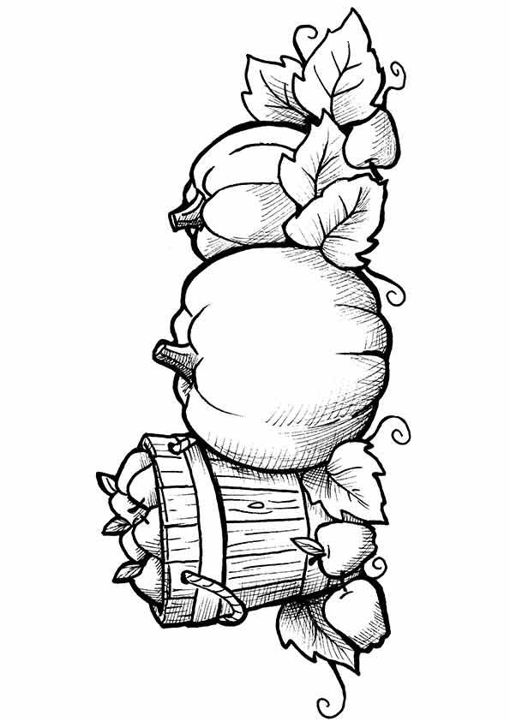

* **October 7 - PLC Day—No Classes**
* **October 10 - Thanksgiving Day—No Classes**
* **October 11 – Picture Day**
* **October 11 - School Pictures**
* **October 13 - Walkathon**
* **October 16-22 – Education/Sk. Library Week**
* **October 17 – Bus Driver Appreciation Day**
* **October 21 – Boston Pizza Lunch**
* **October 31 – Halloween Parade (pm)**



**School News**

**Administrator’s Message - September 2022**

**Summer is over and another school year has just begun and I am so excited for everything that we have in store for our students and families. The summer provided so many beautiful, hot, sunny days and I am feeling fresh and full of enthusiasm!**

**September is shaping up to be a very busy month with classes beginning on Thursday, September 1st for all students in Kindergarten to Grade 8. I can’t wait to see how much everyone has grown over the summer!**

**We have scheduled our Meet the Staff event for the evening of Tuesday, September 13th from 5:30 – 6:30. During this time we invite you to stop by each of your children’s classrooms to meet the teacher. While visiting your child’s teacher be sure to get your child’s entry into our Back to School Fun Basket. The draw will be made later that evening.**

**Following our Meet the Staff event we will be holding our first SCC Meeting of the 2022 – 2023 school year. The meeting will begin at 6:30. Parents are invited to be a part of this meeting. We will be focusing on how the SCC can support all of our school’s activities throughout the year. One of the main topics of discussion will be our Skating Rink Project that has been in the works for the past year. I am so excited to tell you that the Rink is up and ready for flooding. We are looking to put together a Rink Committee to help with the flooding and maintenance of the rink. If you or someone you know has past experience with the rink flood and would be interested in joining this committee or attending to provide some background knowledge it would be greatly appreciated.**

**Once again, I would like to extend our gratitude for all of the support provided for our Rink Project. What had been expected to be a two- to three-year fundraising project was accomplished in the span of only ten months! This is a testament to the generosity and hard work that has kept this community so strong!**

**We are excited to get back to the business of learning and I know that our staff will make this year an amazing year of growth and development and will inspire your children to become life-long learners!**

**I would like to welcome our new staff members. Mrs. Conarroe will be teaching Kindergarten, Ms. Tatlow will be teaching our Grade 3/4 class and Miss Deschambeault will be interning in the Grade 1/2 class. In addition, Mrs. Hufnagel will be our School Social Worker and will be at East Central one day a week to support our students.**

**As always, I am available to discuss anything that may be on your mind. Feel free to call the school or drop in at any time. I am looking forward to reconnecting with our students and our families over the next few weeks.**

**Welcome Back!**

**Mrs. J. Tournier**



**EC Future Events**

**Meet the Staff**

**You are invited to drop in on the evening of Tues., Sept. 13th, between 5:30 pm and 6:30 pm to meet our staff at East Central School, immediately followed by our first SCC meeting of the new school year. Please join us. (See newsletter insert)**

**SCC News**

**The SCC will be holding its first meeting of the 2022-2023 school year on Tues., September 13th immediately following our Meet the Staff hour. Everyone is invited to join us and help plan for the exciting year ahead!**

**Annual Christmas Trade Show**

**East Central School will be hosting our annual Christmas Trade Show on Saturday, November 26th. We look forward to seeing previous year’s participants and would like to extend an invitation to any new vendors that would like to join us for this exciting and well attended event! For more information, please contact the school at 306-922-8329.**

**Registration Updates**

**Please keep the school advised of any changes that should occur during the school year. (Contacts, phone numbers etc.) The best way for us to keep our students safe is for all information to be current! We would like to ask that every student has a local emergency contact number. *The emergency contact must be someone other than the parent/guardian as it is the person we would phone if we were unable to reach the parent/guardian.* Thank you for your cooperation in keeping our students safe while they are in our care.**



**Cross country running has already started at East Central!  We will be attending mini meets in the future.  Dates and locations to be announced.  Extravaganza will happen during the school day and is on Tuesday, Oct. 4th.  The students at East Central have already started practicing.  Any child from grade 4-8 is welcome to take part.  If your child is interested, please have them talk with Mrs. Coombs.**



**Community News**

**CHRISTINA’S ART SCHOOL has a few spots open! Follow your child’s heart… if they love drawing and art, register them soon!  We are now taking registrations for openings in pencil drawing, charcoal, pastels, coloured pencils, acrylic painting & watercolour.  We have taught many students this soul nurturing skill (adults included!).  Whether they develop their love into a hobby, or it’s their launch into a secondary school and career, the skills they acquire will be with them for life!  Classes also include a yearend Field Trip & Art Show.  Online registration is at** [**www.christinathoen.com**](http://www.christinathoen.com)**.  For more info, see Christina’s Art School on Facebook/Instagram, or feel free to phone Christina Thoen, Certified Teacher (Art Major) at (306) 961-3350 for more information and to register by phone!**

**Navy League/ Sea Cadets would like to invite youths aged 9 to 18 years old, to join the leagues on Thursday or Friday evenings. Leaders and volunteers are needed as well. For more information email:**

**Navy League –** [**wkreed5@outlook.com**](mailto:wkreed5@outlook.com) **or Sea Cadets – 118sea@cadets.gc.ca**

**!!LIFE THREATENING ALLERGY IN OUR SCHOOL!!**

**East Central Public School has students attending that have a life threatening allergy to nuts. Our school wants to provide the safest environment possible. PLEASE DO NOT SEND PRODUCTS CONTAINING NUTS OR PEANUTS TO SCHOOL!**

**Please check the ingredients of all foods your child(ren) bring to school. Ensure that you do not send foods with peanuts or any other types of nuts. As well, avoid sending items which say, “May contain traces of nuts,” as these could pose a serious risk.**

**MCj03036750000[1]We wish to thank you for your understanding and support regarding this potentially life threatening allergy. Please contact the school if you have further questions or concerns.**

***Reminder: All schools in the Saskatchewan Rivers Public School Division including East Central are nut free. Please do not send nuts of any kind to school in your child’s lunch or in baking that you bring to the school.***

**MCj03312940000[1]**

***If your child has an allergy that requires special accommodation from the school please pick up an information form from the office to be completed by your allergy specialist.***

***PLEASE NO NUTS OR PRODUCTS CONTAINING NUTS IN THE SCHOOL!***

